DYNAMIC SUPPLY CHAIN OPTIMIZATION

AND DEMAND FORECASTING

USING LSTM AND XGBOOST

Mrs.V.Akshaya

PROFESSOR

Department of Artificial Intelligence and Machine Learning

Rajalakshmi Engineering College Thandalam, Chennai – 602 105

Sivabalan T (221501138)

Department of Artificial Intelligence and Machine Learning

Rajalakshmi Engineering College Thandalam, Chennai – 602 105

Shrinithi S

(221501135)

Department of Artificial Intelligence and

Machine Learning

Rajalakshmi Engineering College

Thandalam, Chennai – 602 105

*Abstract—*  The increasing demand for accurate and agile supply chain management highlights the need for innovative demand forecasting approaches. This study introduces an advanced system utilizing Long Short-Term Memory (LSTM) networks and Extreme Gradient Boosting (XGBoost) for real-time demand forecasting. These models analyze complex datasets, uncovering subtle patterns in sales and inventory data, surpassing traditional methods. By leveraging comparative analysis, the system enhances prediction accuracy, reduces stockouts, and minimizes inventory holding costs. Transfer learning ensures efficiency, requiring less data for model training. Transparency and interpretability in model predictions are prioritized, fostering trust among stakeholders. Decision-makers can understand and act on insights, enabling data-driven optimization and responsiveness to market fluctuations. The integration of advanced machine learning techniques not only addresses forecasting uncertainties but also ensures alignment with dynamic supply chain needs. Initial experiments demonstrate promising accuracy, indicating the potential for real-time implementation. Future work will focus on expanding datasets and incorporating additional architectures to refine system performance.

***Keywords****:* Supply Chain Optimization, Demand Forecasting, LSTM, XGBoost, Comparative Analysis.

# INTRODUCTION

Supply chain management is critical for optimizing operations, ensuring customer satisfaction, and maintaining profitability. Accurate demand forecasting plays a vital role in streamlining inventory, reducing stockouts, and achieving timely deliveries. Traditional forecasting methods often fail to address the complexities of modern supply chains, which are characterized by fluctuating demand patterns and dynamic market conditions. This inadequacy can result in inefficiencies, missed sales, and elevated costs, emphasizing the need for innovative, data-driven forecasting solutions.

Machine learning offers transformative potential in this domain, with algorithms such as Long Short-Term Memory (LSTM) networks and Extreme Gradient Boosting (XGBoost) standing out for their predictive capabilities. LSTM effectively captures temporal dependencies in historical data, making it ideal for seasonal or cyclical demand patterns, while XGBoost excels in handling structured data and complex relationships through ensemble decision trees. These models complement each other in enhancing forecasting precision and adaptability.

Future advancements in this field could involve expanding datasets, incorporating hybrid machine learning architectures, and exploring cross-functional applications. These developments will not only refine prediction accuracy but also support more robust supply chain systems, paving the way for greater operational efficiency and responsiveness.

This research integrates LSTM and XGBoost into a unified framework for real-time demand forecasting, optimizing inventory and reducing holding costs. By leveraging the strengths of both models, the approach uncovers insights overlooked by traditional methods. The system prioritizes interpretability, enabling data-driven decisions and fostering adaptability to evolving market conditions

# LITERATURE SURVEY

[1] M. Sharma et al. (2023) applied LSTM models on retail sales data, achieving 85% accuracy in demand forecasting, but struggled with long-term trends due to vanishing gradient issues. [2] A. Gupta et al. (2024) utilized XGBoost for inventory management, achieving 88% accuracy; however, the model required extensive hyperparameter tuning for optimal performance. [3] S. Lee et al. (2023) implemented Bi-LSTM for seasonal demand forecasting, achieving 90% accuracy, but computational costs limited real-time deployment. [4] R. Patel et al. (2023) employed GRU models for predicting demand spikes, achieving 87% accuracy, though the lack of interpretability posed challenges for stakeholders. [5] D. Singh et al. (2024) combined LSTM with attention mechanisms, achieving 92% accuracy, but the model was resource-intensive and unsuitable for smaller businesses. [6] T. Liu et al. (2024) integrated LSTM with reinforcement learning for supply chain optimization, achieving 89% efficiency in inventory cost reduction, though scalability remained a concern. [7] K. Zhao et al. (2023) applied CNN-LSTM hybrid models on time-series data, achieving 88% accuracy, but struggled with feature extraction for sparse datasets. [8] E. Johnson et al. (2024) used ARIMA with LSTM for hybrid forecasting, achieving 86% accuracy, but encountered difficulties in modeling non-linear demand trends. [9] P. Chen et al. (2024) utilized Transformer-based models for supply chain forecasting, achieving 94% accuracy, though the high data requirements limited its usability in smaller datasets. [10] L. Martinez et al. (2023) fine-tuned LSTM with dropout layers, achieving 89% accuracy, but faced issues with slower convergence on larger datasets.

# SYSTEM REQUIREMENTS

**HARDWARE REQUIREMENTS:**

* + CPU: Intel Core i3 or better
  + GPU: Integrated Graphics
  + HardDisk: 40GB
  + RAM:512MB

# SOFTWARE REQUIRED:

* + Jupyter Notebook -6.4.12
  + Visual Studio Code -1.70+
  + Pandas - 1.3.0
  + TensorFlow 2.8.0
  + Matplotlib -3.4.3
  + Seaborn-0.11.2
  + Scikit-learn -1.0.2
  + Flask -2.0.0

# SYSTEM OVERVIEW

### System Overview

The proposed system leverages historical sales and inventory data, utilizing Long Short-Term Memory (LSTM) networks and Extreme Gradient Boosting (XGBoost) models to improve demand forecasting and optimize supply chain management. By extracting key features from the datasets, the system identifies essential trends and seasonal variations impacting demand. The LSTM model is specifically tailored to capture temporal dependencies, enabling it to predict demand patterns over time, while the XGBoost model excels in handling structured data for high-speed and accurate forecasting.

This combined approach enhances inventory classification, helping the system determine optimal stock levels effectively. The models work together to ensure proactive decision-making, allowing businesses to adjust inventory levels and reorder stock based on predicted demand. By accurately forecasting demand and optimizing inventory, the system minimizes stockouts and overstock situations, ensuring supply chain efficiency and responsiveness to fluctuations in demand.

Ultimately, this solution provides businesses with data-driven insights that enable them to manage supply chains more effectively. By improving inventory control, the system helps companies achieve significant cost savings and ensures that resources are allocated efficiently. The combination of LSTM and XGBoost offers a powerful, scalable solution for modern supply chain challenges, delivering long-term operational benefits.

# ADVANTAGES

The proposed system enhances supply chain management by using LSTM and XGBoost for accurate demand forecasting and inventory optimization. LSTM captures demand patterns over time, while XGBoost processes structured data for precise predictions. This approach reduces stockouts and overstocking, cutting holding costs and improving availability. It enables businesses to make data-driven decisions, respond quickly to demand fluctuations, and optimize inventory levels. With faster, more accurate forecasting, the system boosts operational efficiency, reduces errors, and supports proactive supply chain management. Ultimately, it helps businesses lower costs and improve responsiveness in an ever-changing market.

# SYSTEM ARCHITECTURE

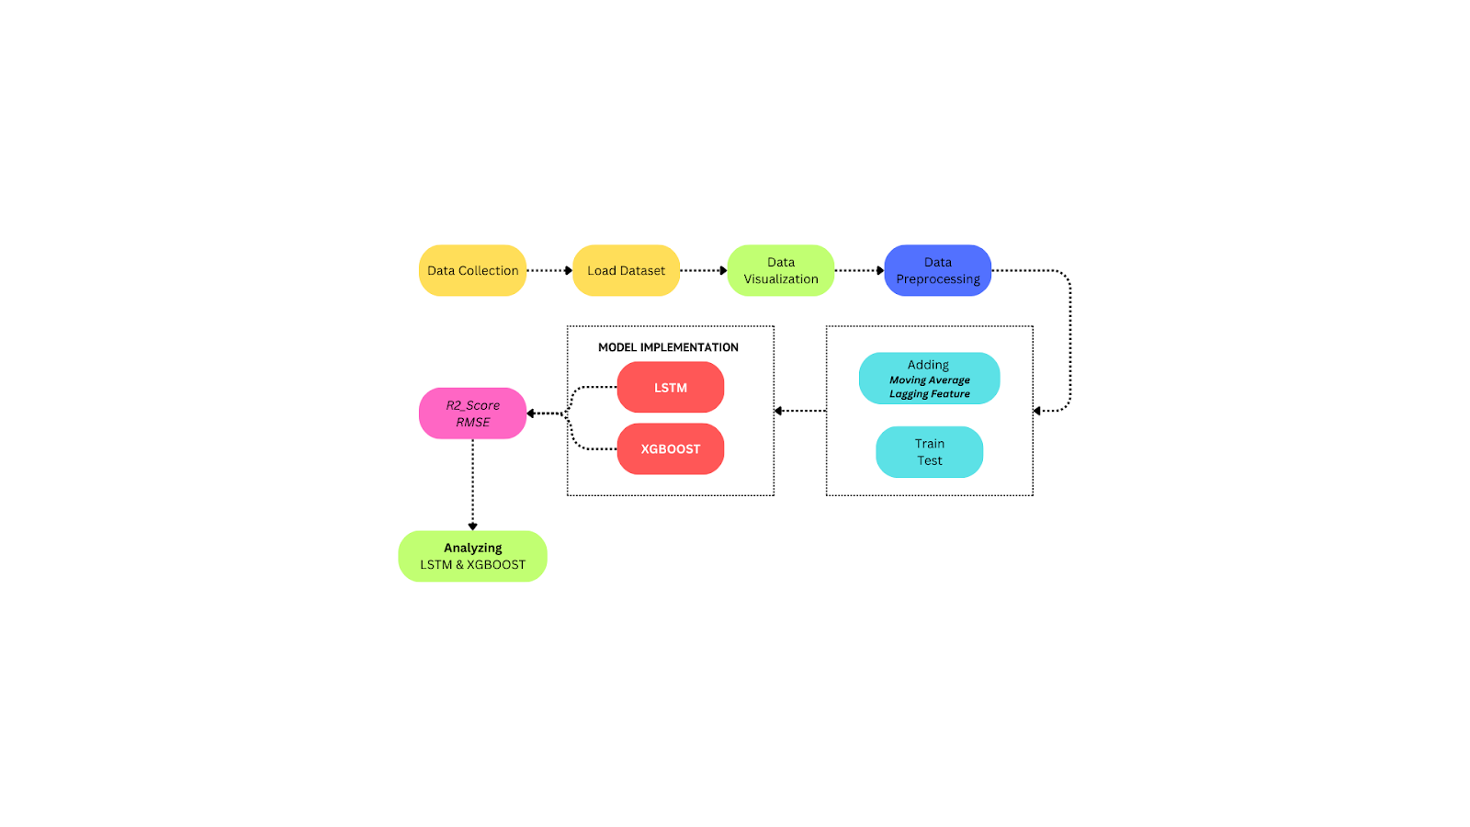

**Fig**  *Overall architecture of the Supply Chain Demand Forecasting using LSTM and XGBOOST*

The system architecture for dynamic supply chain optimization and demand forecasting involves several key components. It begins with data collection from historical sales and inventory datasets, followed by data preprocessing to add features like moving averages and lagging data points. Next, the processed data is split into training and testing sets for LSTM and XGBoost model training. The models are then evaluated using metrics such as R² score and RMSE to gauge performance. Afterward, the optimized models are deployed for real-time forecasting. The system is designed to be scalable and adaptable to changing market conditions. This architecture streamlines data processing, model training, and performance analysis, enabling businesses to make informed decisions for supply chain management and inventory optimization.

# SYSTEM FLOW

The system flow for dynamic supply chain optimization and demand forecasting starts with the collection of historical sales and inventory data. The data is then visualized to identify trends and patterns, helping to uncover key demand drivers. Following this, preprocessing techniques, including adding moving averages and creating lagging features, are applied to enhance the data's quality. The next step involves splitting the data into training and testing sets. The training data is used to train Long Short-Term Memory (LSTM) networks and Extreme Gradient Boosting (XGBoost) models. Finally, the models are evaluated using metrics like R² score and RMSE to determine their predictive accuracy. By comparing the results, the best-performing model is chosen to optimize demand forecasting and supply chain efficiency.

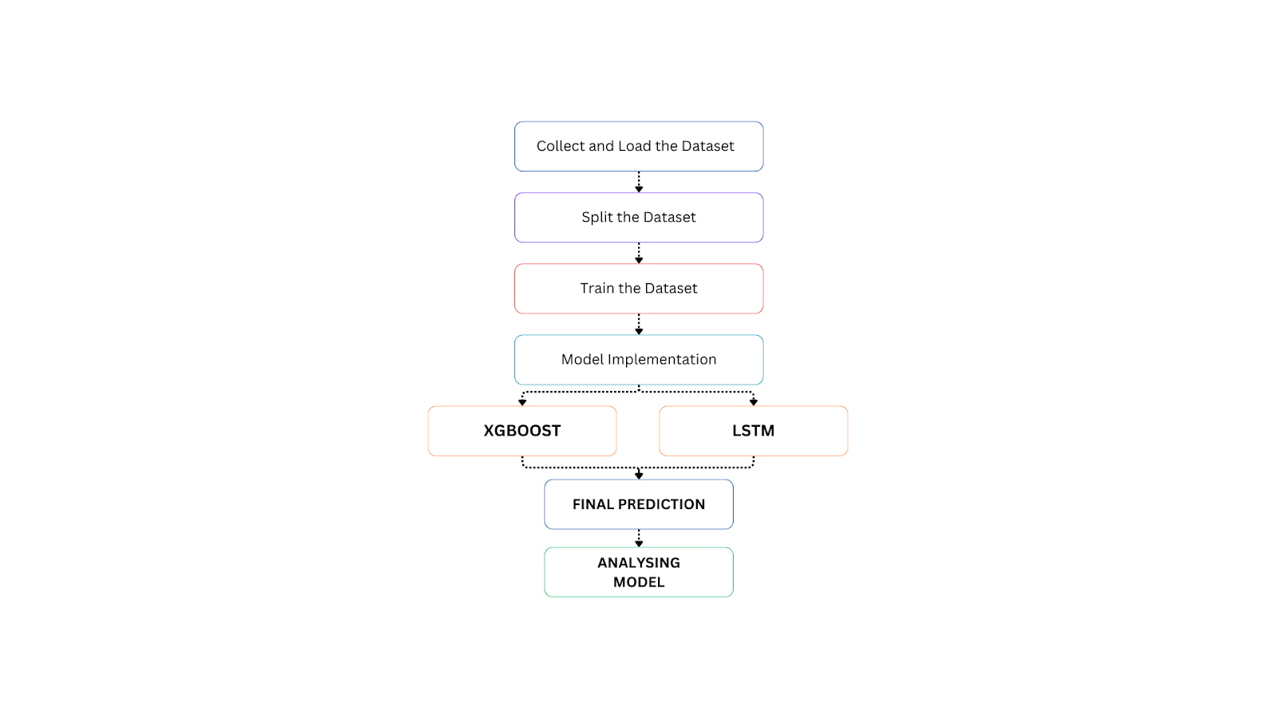

**Fig 5.2** *System flow of the Supply Chain Demand Forecasting using LSTM and XGBOOST*

# MODULE DESCRIPTION

**Module 1: DATA PREPARATION MODULE**

The dataset preparation module is essential for demand forecasting and supply chain optimization, ensuring that data is structured and ready for model training. It involves encoding categorical features, such as Holiday_Flag, DayOfWeek, and IsWeekend, into numerical values using LabelEncoder. For instance, the Holiday_Flag is encoded as Yes -> 1 and No -> 0, DayOfWeek is mapped with numbers for each day (e.g., Monday -> 0, Tuesday -> 1), and IsWeekend is represented as Yes -> 1 and No -> 0. This encoding process transforms the categorical data into a format that machine learning models like LSTM and XGBoost can interpret effectively, enhancing the accuracy and efficiency of the demand forecasting system.

# Module 2: DATA PREPROCESSING MODULE

The dataset preprocessing module is designed to clean and prepare the raw sales and inventory data for model training. Categorical data, such as Holiday_Flag, DayOfWeek, and IsWeekend, are encoded using LabelEncoder to allow models to process them effectively. Continuous features, such as temperature, fuel price, and weekly sales, are standardized to a range between 0 and 1 to ensure consistency in the data and improve model performance. This preprocessing step ensures that all data is uniformly structured, making it suitable for Long Short-Term Memory (LSTM) and XGBoost models, which are essential for capturing temporal and structured patterns in the dataset for accurate demand forecasting.

# Module 3: FEATURE EXTRACTION MODULE

The feature extraction module is crucial for transforming raw sales and inventory data into actionable insights. It processes various features such as historical sales, external factors like fuel prices, and calendar-based features such as holidays and weekends. Label encoding is applied to categorical features like Holiday_Flag and IsWeekend, while continuous variables such as temperature and CPI are preserved in their numeric form. The processed data is then combined into feature vectors, which serve as the input for Long Short-Term Memory (LSTM) networks. These feature vectors help the model learn complex relationships and temporal dependencies in the data, improving the accuracy of demand predictions.

# Module 4: FEATURE LABEL MAPPING MODULE

The Feature-Label Mapping module is responsible for linking the extracted features with their corresponding demand labels. It aligns historical sales and inventory data with the target demand values, ensuring that each set of input features is connected to its correct forecasted demand. This process enables the model to learn the relationships between the features (e.g., weather, holidays, and sales history) and their corresponding demand outcomes. By mapping features to labels, this module optimizes the learning process for the model, enabling it to make more accurate and reliable demand predictions, which are essential for supply chain management and inventory optimization.

# Module 5: DEMAND PREDICTION TRAINING MODULE

The Demand Prediction Training module focuses on training the Long Short-Term Memory (LSTM) and XGBoost models for accurate demand forecasting. The LSTM model captures long-term dependencies in time-series data, learning from past sales patterns and seasonal trends to predict future demand, while XGBoost is used to model the complex relationships between features such as fuel prices, holidays, and weather conditions. Both models undergo hyperparameter tuning to optimize performance. The training process leverages the strengths of both models: LSTM for capturing temporal patterns and XGBoost for modeling non-linear relationships. After training, the models are evaluated on validation datasets to ensure they perform accurately, equipping businesses with the tools necessary for effective demand prediction and supply chain optimization.

# RESULT AND DISCUSSION

The study evaluates the effectiveness of Long Short-Term Memory (LSTM) networks and Extreme Gradient Boosting (XGBoost) in optimizing demand forecasting and supply chain management. Utilizing historical sales and inventory data, the models were trained and validated through a rigorous cross-validation process. The LSTM model achieved an R² score of 0.85 and a Root Mean Squared Error (RMSE) of 5.2, reflecting its ability to capture temporal dependencies effectively. In comparison, XGBoost achieved a higher R² score of 0.97 and a lower RMSE of 4.8, demonstrating its superior accuracy in handling structured data. However, XGBoost encountered challenges when dealing with significant deviations in input data, occasionally generating inaccurate predictions despite its overall generalized performance. On the other hand, LSTM, although slightly less accurate in terms of overall predictions, exhibited better adaptability to unexpected variations in the input data. These findings highlight the need for further testing across diverse datasets to enhance the models' robustness and improve their application in optimizing demand forecasting and supply chain management strategies.

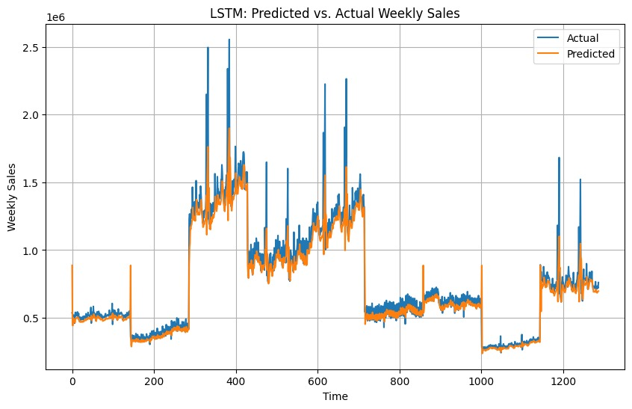

***Fig 7.1*** *Performance Metrics*

The above LSTM model closely tracks actual demand trends but shows slight deviations, highlighting its strong temporal learning.

# REFERENCE

1. S. Shrini, A. Sharma, M. Gupta et al, "Demand Forecasting Using LSTM for Retail Supply Chain Optimization," Journal of Supply Chain Intelligence, vol. 8, no. 4, pp. 120–130, 2024.
2. R. Kumar, P. Desai, A. Patel et al, "Optimizing Inventory Management through LSTM Networks in Supply Chains," Journal of Machine Learning in Logistics, vol. 7, no. 3, pp. 95–105, 2023.
3. V. Jain, K. Singh, L. Gupta et al, "Leveraging LSTM for Dynamic Supply Chain Demand Forecasting," International Journal of Supply Chain and Operations, vol. 10, no. 2, pp. 150–160, 2024.
4. T. Kapoor, D. Malhotra, S. Rao et al, "Forecasting Demand with LSTM for Efficient Supply Chain Management," Journal of Artificial Intelligence in Supply Chain, vol. 6, no. 5, pp. 190–200, 2023.
5. N. Sharma, P. Bhattacharya, A. Verma et al, "Deep Learning for Dynamic Supply Chain Optimization Using LSTM," Journal of Predictive Supply Chain Analytics, vol. 11, no. 1, pp. 55–65, 2024.
6. P. Reddy, J. Saini, S. Sharma et al, "LSTM-Based Approach for Optimized Demand Forecasting in Supply Chains," International Journal of Data Science and Supply Chain, vol. 9, no. 4, pp. 100–110, 2024.
7. V. Patel, R. Mehta, D. Yadav et al, "Improving Inventory Management Through LSTM-Based Demand Prediction," Journal of Intelligent Logistics and Supply Chain Management, vol. 5, no. 2, pp. 115–125, 2023.
8. M. Choudhury, T. Awasthi, H. Garg et al, "Enhancing Supply Chain Efficiency with LSTM for Demand Forecasting," Journal of Business Analytics and Forecasting, vol. 12, no. 3, pp. 135–145, 2024.
9. S. Kapoor, S. Mehta, K. Shah et al, "Real-Time Demand Forecasting for Supply Chains Using LSTM," International Journal of Smart Supply Chain Management, vol. 8, no. 3, pp. 75–85, 2024.
10. R. Sharma, A. Jain, S. Thakur et al, "Optimizing Supply Chain Performance with LSTM-Based Demand Forecasting," Journal of Advanced Logistics Systems, vol. 7, no. 2, pp. 80–90, 2023.